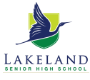
TASK 9: DNA, Cells and Reproductive Systems Test
HUMAN BIOLOGY GENERAL YEAR 11
ANSWER BOOKLET

NAME:

CLASS: DATE:

Multiple Choice Short Answer Total

/
3

/15

/28

Time allowed –Working time for paper 55 minutes

Instructions to candidates
Answer the multiple-choice questions on the answer sheet provided.
Write your answers to the short answer section in the spaces provided beneath each question
Answers that require a numerical answer should show all working out in logical steps.
Candidates should write clearly with a pen unless otherwise directed
SECTION ONE: Multiple choice answers
Cross (X) through the correct answer.

1 | a | b | c | d
2 | a | b | c | d
3 | a | b | c | d
4 | a | b | c | d
5 | a | b | c | d
6 | a | b | c | d
7 | a | b | c | d
8 | a | b | c | d
9 | a | b | c | d
10 | a | b | c | d
11 | a | b | c | d
12 | a | b | c | d
13 | a | b | c | d
14 | a | b | c | d
15 | a | b | c | d

Part A: Multiple choice (10 marks)

This section has 15 questions. Answer all questions on the multiple-choice answer sheet.

- DNA is located in the nucleus. Where else in the cell is DNA found?

  - ribosomes
  - mitochondria
  - golgi body
  - centrioles

- The function of the testes is to

  - carry sperm to the urethra.
  - produce seminal fluid.
  - produce sperm.
  - pass out urine.

- Image below depicits which phase of meiosis?

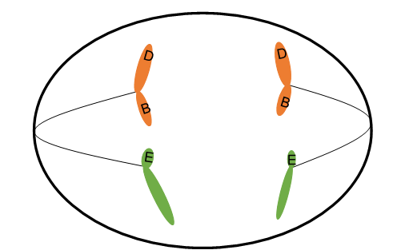

  - Metaphase I.
  - Metaphase II.
  - Anaphase I.
  - Anaphase II.

- In meiosis, the chromosome number is halved in order to

  - ensure the DNA is copied completely.
  - maintain all the DNA in the daughter cells.
  - ensure that errors in crossing-over can be corrected at fertilisation.
  - maintain the correct chromosome number in offspring.

- During mitosis, cells

  - divide once to produce two identical cells.
  - divide once to produce two new cells that show some variation.
  - are able to unite with other cells that are produced.
  - divide twice to produce four new cells.

The next three questions refer to the diagram below:
- The structure that produces the ovum is

  - A
  - B
  - C
  - E

- The Part B in the diagram is called the:

  - ovary
  - fallopian tube
  - uterus
  - vagina

- Which of the following is not a function of the part labelled B?

  - development of the placenta.
  - development of the ova.
  - where implantation of the fertilised egg occurs.
  - growth and development of foetus.

- Which of the following is not correct regarding formation of sperm?

  - it begins before birth, then ceases until after puberty
  - it occurs continually after puberty
  - the process takes about 72 days
  - one gamete results in four viable spermatozoa

- The part of the DNA molecule below in the shaded box labelled ‘A’ is a
  - deoxyribose sugar.
  - ribose sugar.
  - peptide.
  - nucleotide.

- In human’s normal body cells contain 46 chromosomes. How many chromosomes are in the sex cells?

  - 46
  - 23
  - 92
  - 12

- The function of the uterus is

  - a place where the fertilised ovum can develop.
  - to destroy sperm.
  - to produce the ovum.
  - to carry the sperm to the uterus.

The following three questions refer to the diagram below

- What is the name of structure C in the diagram?

  - DNA
  - nucleotide
  - chromosome
  - gene

- What is the name of the part labelled A, on the diagram above?

  - DNA
  - centromere
  - chromatid
  - chromosome

- The part labelled B on the diagram above is called

  - DNA
  - centromere
  - chromatid
  - chromosome

Part B: Short answer (31 marks)
Answer all questions in the spaces provided.
- There are four different nitrogen bases in the DNA molecule and they only pair with each other in a certain way. What are the four nitrogen bases and which nitrogen bases pair with each other? (2 marks)
_____________Correct Names _
______Adenine Pairs with Thymine____________Cysteine pairs with Guanine______
- What is the function of DNA? (1 marks)
_________The instructions for making all structures and materials the body needs to function______

- The following parts of Question 11 refer to the diagram of the male reproductive system shown below.

  - Identify the structures labelled C and D. (2 marks)
Structure C: _____________ Prostate gland __________________________
Structure D: _____________ Epididymis __________________________

  - State the function of the structures labelled C and D (2 marks)
Structure C: _______________ Produces fluid to protect sperm/add to semen __________________________
Structure D: _____________________ Storage of sperm __________________________________________
  - Name and explain the role of the secretion that carries sperm through the reproductive tract. (4 marks)
Semen (1 mark)
They provide a medium through which sperm can swim. (1 mark)
They are the main source of energy for sperm. (1 mark)
neutralize the acidic environment in the female vagina prolonging their life of sperm (1 mark)

  - The testes develop in the abdominal cavity and then descend into the scrotal sac. Why is it necessary for the testes to be outside the body in this way? (1 mark)
_maintain optimum temperature for viable sperm________________________________
- The diagram below represents a male sex cell and its chromosomes before meiosis division.
  - In the space below, draw a representation of the cell is it would appear during Prophase 1. Indicate chromosomes only: do not show organelles. (2 marks)

Correct drawing of chromosomes. Evidence of crossover or genetic exchange

- In the space below, draw a representation of the daughter cells produced at the end of meiosis division. Indicate chromosomes only: do not show organelles. (2 marks).

Correct drawing of 4 eggs with the different chromosomes. Evidence of crossover or genetic exchange in at least two chromosomes.

- Complete the following diagram which represents the process of fertilisation. (3 marks)

Name: __SPERM______________
Number of chromosomes: __23______
Name: _________OVUM_______
Number of chromosomes: _23_______
Name: ___ZYGOTE_____________
Number of chromosomes: __46_

- The diagram below represents the menstrual cycle and shows the levels of hormones.
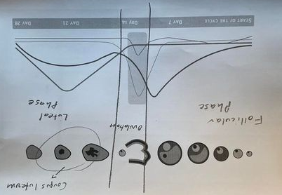
- Mark the labels below on the diagram above. 4 marks
Corpus Luteum, Ovulation, Follicular Phase, Luteal Phase,

- Complete the table below by describing the function of the four main hormones involved in menstruation and ovulation in the female. 4 marks
Hormone | Function
Oestrogen | Estrogen plays a role in ovulation (when your ovaries release an egg) and thickens the lining of your uterus (endometrium) to prepare it for pregnancy..
Progesterone | Progesterone builds up the lining of the uterus called the endometrium in preparation for the fertilized ovum
Follicle Stimulating Hormone (FSH) | helps control the menstrual cycle and stimulates the growth of eggs in the ovaries
Lutenizing Hormone (LH) | triggers the release of an egg from the ovary.

Short Answer Question
State three functions of each of the following: (9 marks)

Vagina:
- provides a passageway for blood and mucosal tissue from the uterus during a woman’s monthly period
- receives the penis during sexual intercourse and holds the sperm until they pass into the uterus
- provides a passageway for childbirth

Cervix:
- Producing cervical mucus during the most fertile phase of the menstrual cycle, which helps sperm travel from the vagina into the uterus
- Opening during labor to allow the baby to pass through the birth canal
- Protecting the uterus from bacteria and other foreign objects

Fallopian tubes:
- carry ovum from the ovary to the uterus
- Transport of human sperm
- Environment for fertilisation

End of Test

